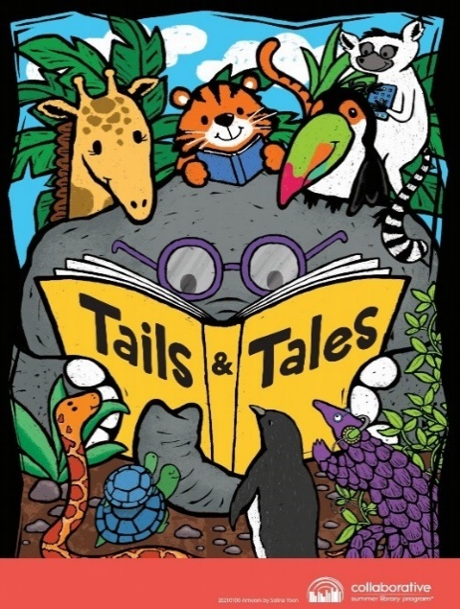
NEWPORT CULTURAL CENTER
2021 SUMMER READING CHALLANGE
How it works:
- For kids ages 0-12-children who read at least 15 minutes a day, five days a week will earn brag tags and prizes weekly. For each completed week of reading your name is also entered to win prizes at our Summer Reading Party.
- For teens: ages 13-18-for each week teens complete their weekly reading they will be entered to win prizes. Each completed book review will also earn a prize entry.
- For adults ages 19 and over-track your reading, get recommendations, and see how your progress compares with others in your community. Three participants will win certificates to local businesses.
Children and teens will receive a reading log to keep track of books and minutes read. For every week of reading they complete and turn into NCC librarians there are brag tags and prizes to win. Attendance at summer programs also earns an extra entry for Summer Reading Party prizes.

NAME:
ADDRESS:
PHONE:
EMAIL:
AGE: GRADE IN SEPTEMBER:
Please list any additional family participating in the summer reading challenge. Use back of paper if necessary.
NAME, AGE & GRADE:

NAME, AGE & GRADE:

YES
My child can be photographed for pictures used for area newspapers and for the Library's Facebook page. NO

Signature: _____________________________________

